DAY 7

DAY7 -1

package D7;

import org.openqa.selenium.WebDriver;

import org.openqa.selenium.chrome.ChromeDriver;

import org.openqa.selenium.chrome.ChromeOptions;

import org.testng.Assert;

import org.testng.annotations.Test;

import io.github.bonigarcia.wdm.WebDriverManager;

public class D71 {

@Test

public void method1() {

WebDriverManager.chromedriver().setup();

ChromeOptions co=new ChromeOptions();

co.addArguments("--remote-allow-origins=*");

WebDriver driver=new ChromeDriver(co);

driver.get("https://demo.wpeverest.com/user-registration/guest-registration-form/");

String actualtitle=driver.getTitle();

String expectedtitle="Guest Registration Form-User Registration";

Assert.assertEquals(actualtitle, null);

}

}

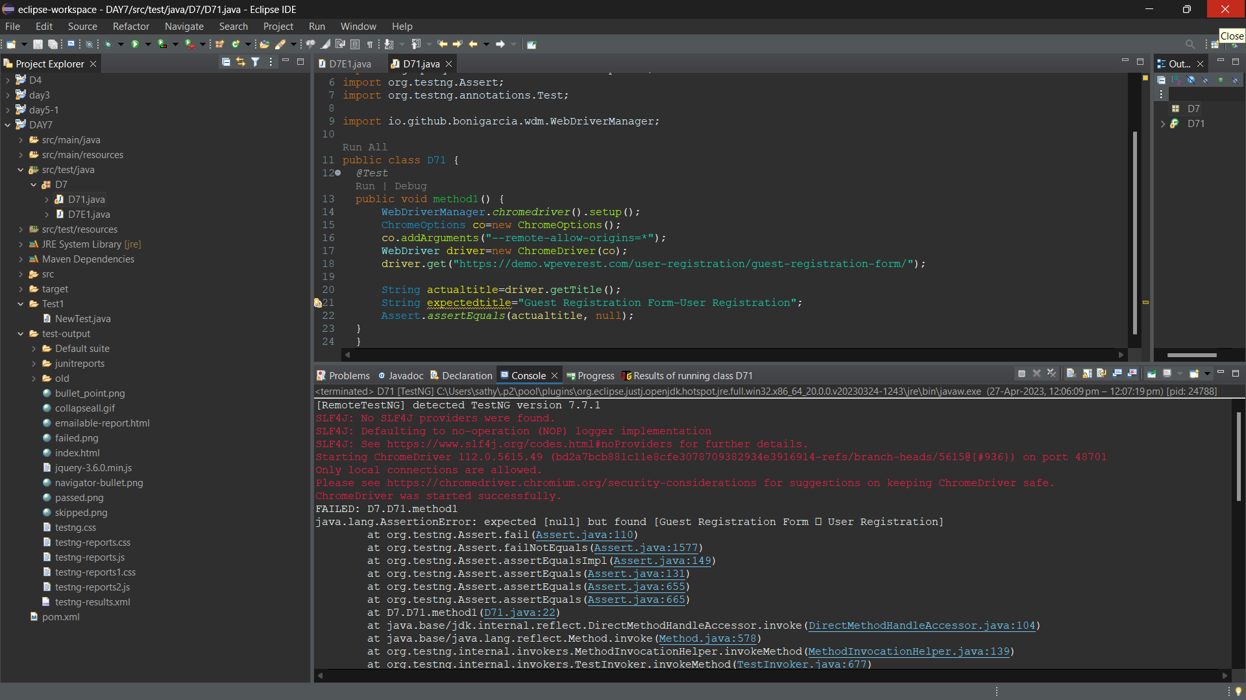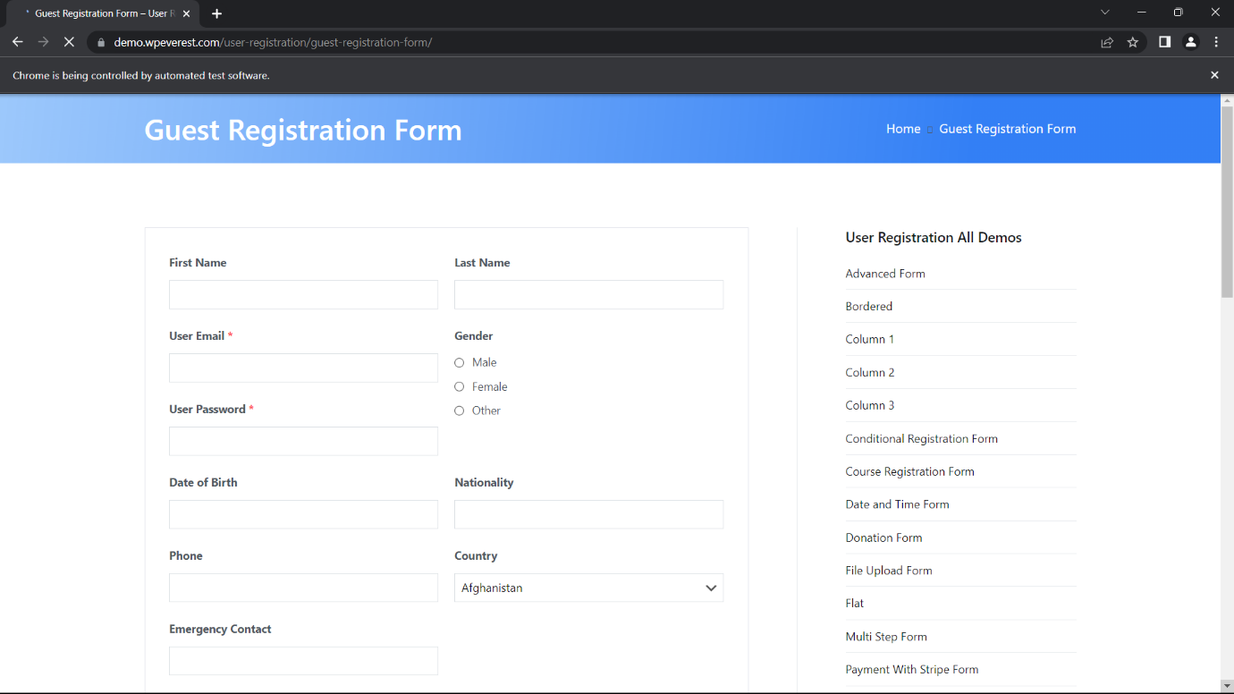

DAY 7 -2:

package D7;

//import java.util.Scanner;

import org.testng.Assert;

import org.testng.annotations.BeforeSuite;

import org.testng.annotations.Test;

public class D7E2 {

int a,b,c;

@BeforeSuite

void getdata(){

// System.out.println("Enter the values to calculate:");

// Scanner sc=new Scanner(System.in);

// a=sc.nextInt();

// b=sc.nextInt();

// c=sc.nextInt();

a=7;

b=4;

}

@Test

public void add() {

c=a+b;

Assert.assertEquals(c,11);

}

public void sub() {

c=a-b;

Assert.assertEquals(c, 3);

}

public void mul() {

c=a*b;

Assert.assertEquals(c, 28);

}

public void div()

{

Assert.assertEquals(c, 1);

}

}

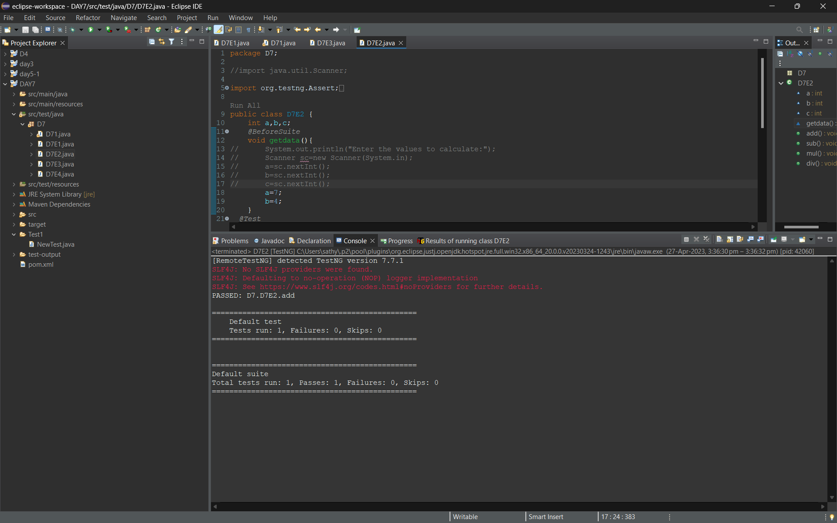

DAY 7-3:

package D7;

import org.testng.annotations.Test;

import io.github.bonigarcia.wdm.WebDriverManager;

import org.testng.annotations.BeforeMethod;

import org.testng.annotations.AfterMethod;

import org.openqa.selenium.By;

import org.openqa.selenium.WebDriver;

import org.openqa.selenium.WebElement;

import org.openqa.selenium.chrome.ChromeDriver;

import org.openqa.selenium.chrome.ChromeOptions;

import org.testng.Assert;

public class D7E3 {

WebDriver driver;

@Test

public void openURL() throws InterruptedException {

Thread.sleep(3000);

WebElement userName = driver.findElement(By.name("username"));

WebElement password = driver.findElement(By.name("password"));

WebElement submit = driver.findElement(By.xpath("//*[@class='oxd-button oxd-button--medium oxd-button--main orangehrm-login-button']"));

userName.sendKeys("Admin");

password.sendKeys("admin123");

submit.click();

Thread.sleep(3000);

String expectedURL = "https://opensource-demo.orangehrmlive.com/web/index.php/dashboard/index";

//String expectedURL = "https://opensource-demo.orangehrmlive.com/web/index.php/auth/login";

String actualURL = driver.getCurrentUrl();

Assert.assertEquals(expectedURL, actualURL);

}

@BeforeMethod

public void setup() {

//System.setProperty("webdriver.chrome.driver","C:\\Users\\tharu\\Downloads\\chromedriver_win32\\chromedriver.exe");

WebDriverManager.chromedriver().setup();

ChromeOptions co = new ChromeOptions();

co.addArguments("--remote-allow-origins=*");

driver = new ChromeDriver(co);

driver.manage().window().maximize();

String url = "https://opensource-demo.orangehrmlive.com/web/index.php/auth/login";

driver.get(url);

driver.manage().window().maximize();

}

@AfterMethod

public void teardown() {

driver.close();

}

}

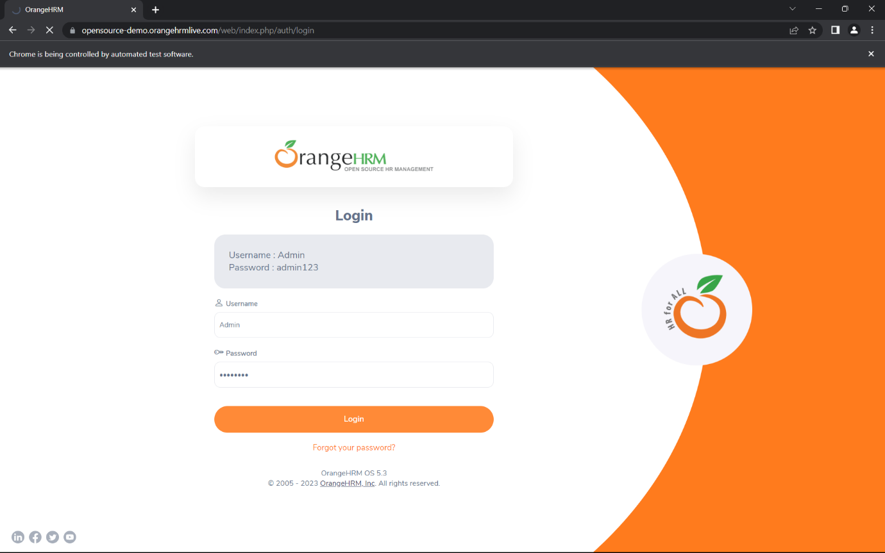

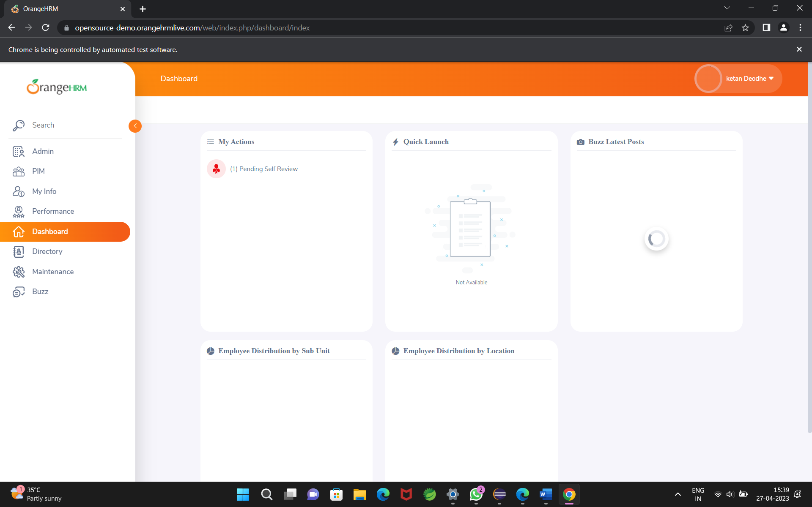

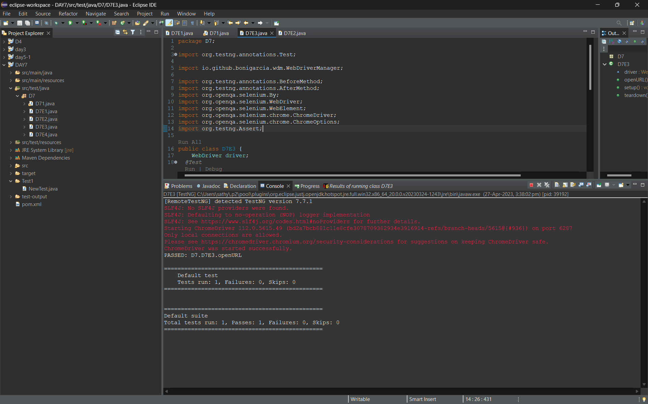

DAY 7-4

package D7;

import org.openqa.selenium.By;

import org.openqa.selenium.chrome.ChromeOptions;

import org.openqa.selenium.edge.EdgeDriver;

import org.testng.Assert;

import org.testng.annotations.Test;

import io.github.bonigarcia.wdm.WebDriverManager;

public class D7E4

{

EdgeDriver driver= new EdgeDriver();

@Test

public void LoginPage() throws InterruptedException

{

WebDriverManager.chromedriver().setup();

ChromeOptions co = new ChromeOptions();

co.addArguments("--remote--allow-origins=*");

driver.get("https://opensource-demo.orangehrmlive.com/web/index.php/dashboard/index");

driver.manage().window().maximize();

Thread.sleep(6000);

driver.findElement(By.xpath("//*[@id=\"app\"]/div[1]/div/div[1]/div/div[2]/div[2]/form/div[1]/div/div[2]/input")).sendKeys("Admin");

driver.findElement(By.xpath("//*[@id=\"app\"]/div[1]/div/div[1]/div/div[2]/div[2]/form/div[2]/div/div[2]/input")).sendKeys("admin123");

String str = driver.getCurrentUrl();

driver.findElement(By.xpath("//*[@id=\"app\"]/div[1]/div/div[1]/div/div[2]/div[2]/form/div[3]/button")).click();

String after= driver.getCurrentUrl();

Assert.assertNotEquals(str,after);

}

@Test(dependsOnMethods="LoginPage")

public void Signout() throws InterruptedException

{

Thread.sleep(6000);

driver.findElement(By.xpath("//*[@id=\"app\"]/div[1]/div[1]/header/div[1]/div[2]/ul/li/span")).click();

String before = driver.getCurrentUrl();

driver.findElement(By.xpath("//*[@id=\"app\"]/div[1]/div[1]/header/div[1]/div[2]/ul/li/ul/li[4]/a")).click();

String after = driver.getCurrentUrl();

Assert.assertNotEquals(before, after);

}

}

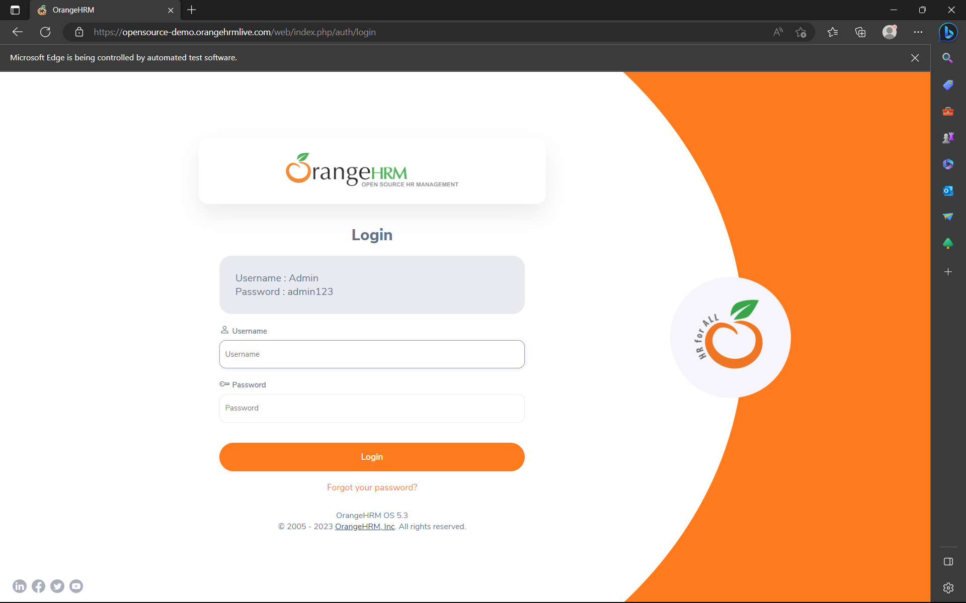

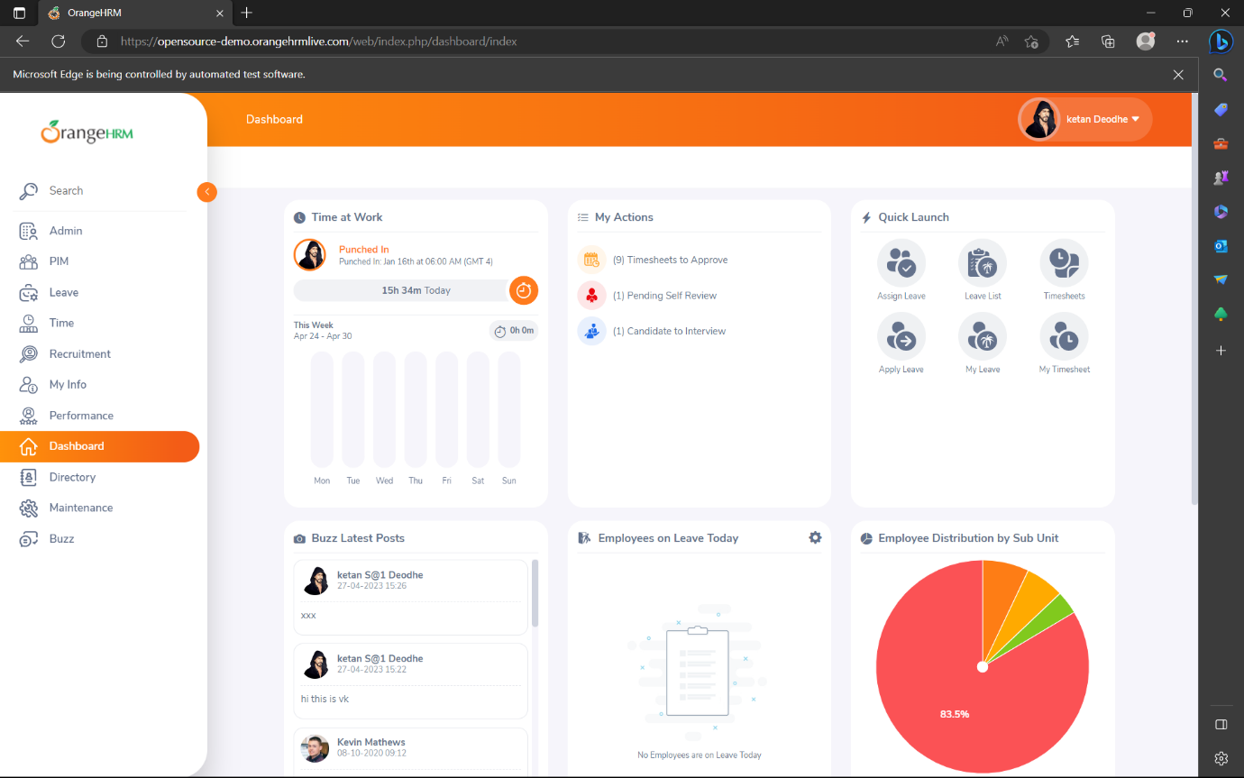

DAY 7-5: